**BUILD A WEB BASED APPLICATION USING NODE RED**

**SMART FARMING – AN IOT ENABLED SMART FARMING APPLICATION**

**TEAMID: PTN2022TMID03145**

**1.Connecting the nodes as shown below**

Iot domain - IN node

Project submission -Function node

Display panel -Template node

IoT domain (selected on the screen) -Response node

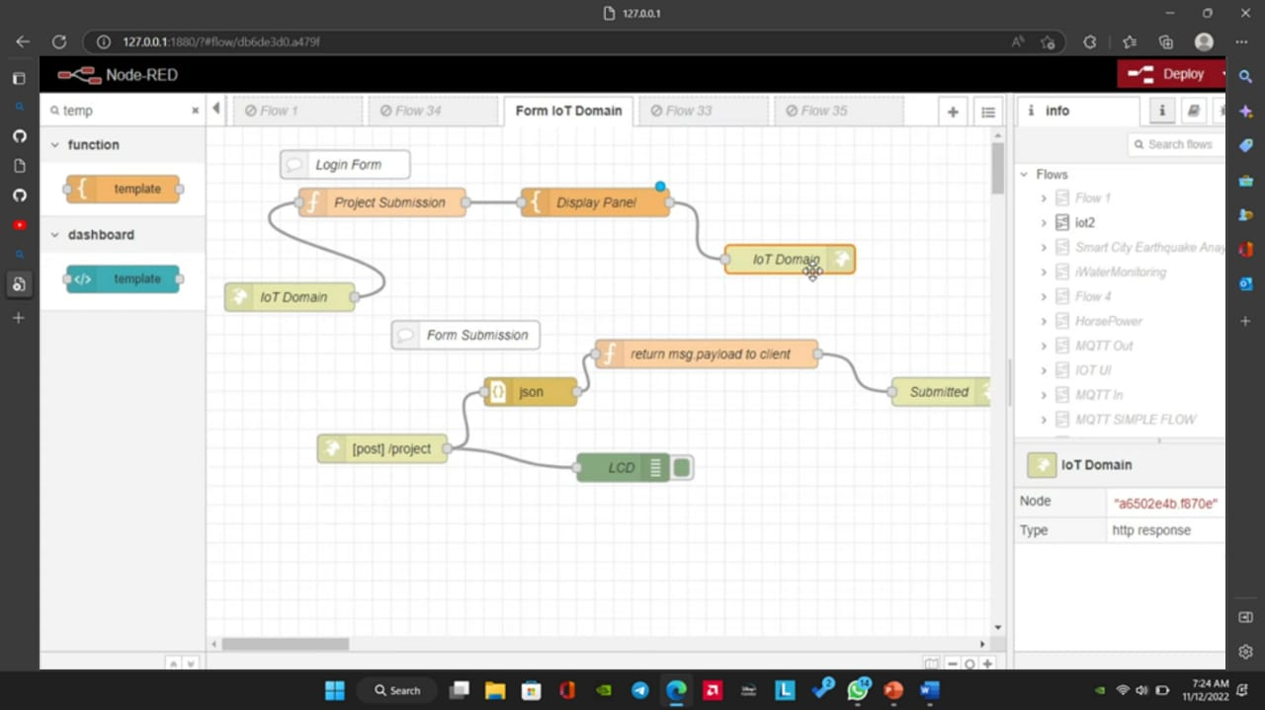

**2.Designing the structure of the web page**

Code used: HTML

**The HyperText Markup Language or HTML** is the standard markup language for documents designed to be displayed in a web browser. It can be assisted by technologies such as Cascading Style Sheets and scripting languages such as JavaScript.

Web template system: Mustache

**Mustache** is a logic-less templating system. A Mustache template is a text string containing text and tags that represent data. The Mustache rendering engine takes a template and substitutes the tags with the data from a given data context.

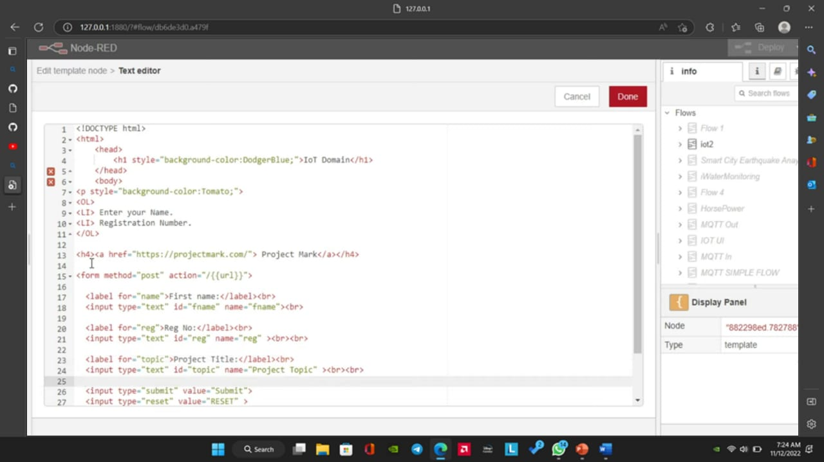

**3.FINAL OUTPUT**

